North winchester flood defences feasibility report

study area including:

St Bedes School, River Park Leisure Centre, Park Avenue, Durngate, winchester school of art

Prepared by: Simon Baker Signed: . . . . . . . . . . . . . . . . . Date: 18/11/2015

Checked by: Simon Fryer Signed: . . . . . . . . . . . . . . . . . Date: 18/11/2015

Approved by: David Ryder Signed: . . . . . . . . . . . . . . . . . Date: 18/11/2015

Job No: R.J511079.03

C O N T E N TS

1.0 Introduction 1
2.0 Design Flood Level 1
3.0 Proposed Flood Defences 2
4.0 Flood Modelling 4
5.0 Discrepancy within the Flood Model 7
6.0 Budget Cost Estimate & Scheme Funding 8
7.0 Cost benefit Analysis 9
8.0 Conclusion 11

1.0 Introduction

This report has been prepared on behalf of Winchester City Council (WCC), Hampshire County Council (HCC), Southampton University (SU) & the Environment Agency (EA) and looks at the feasibility of creating flood defences to protect properties and assets to the north of Winchester city centre against fluvial flooding from the River Itchen.

The River Itchen flows from its source, south of Cheriton, through the City of Winchester to Southampton Water. The Itchen flows is restricted through Winchester by the Durngate Sluice, City Mill and Wharf Mill.

The River Itchen is a chalk stream and is fed by groundwater. During prolonged periods of rainfall the ground water levels rise resulting in an increase in water level of the river.

Historically, the River Itchen flooded in 1852, 1903, 1928, 1935 and 1947. The greatest flooding occurred in the winter of 2000-2001, with significant damage to properties and assets within Winchester. The latest flooding occurred in the winter of 2013-2014 where a well-managed flood response from HCC, WCC and the EA prevented significant damage to properties and assets from occurring. The response involved a great deal of intensive work and associated resources provided through joint agency working and with government support.

Engineering Consultancy have been appointed to review the flooding to the north of Winchester city centre and to provide proposals for flood defences to reduce the risk of flooding and the resources required in future flood events.

2.0 Design Flood Level

The EA produces floodplain maps for the UK which show the areas at risk of fluvial and tidal flooding. The magnitudes of the flooding events considered are defined in terms of their annual event probability. Generally, when determining the impact of any development within the floodplain of a fluvial reach, the design standard against which flood risk is assessed is typically the 1% annual probability flood (1 in 100 year return period flood) for sites within the fluvial floodplain, or the effects of a 1 in 100 year storm if outside the floodplain.

The flood maps combine detailed local data from modelling and mapping studies with information from a national model of England and Wales. For rivers, detailed survey data gives information about the topography or ground surface, and is combined with information on flows.

The Environment Agency recommended that a design flood level of 37.50m Above Ordnance Datum (AOD) (i.e above sea level) should be used for flood defence design. This is 100mm above the 1 in 100yr plus climate change design water level. Further flood modelling has been undertaken to identify the final design height.

Proposed Flood Defences

The proposed flood defences will consist of permanent walls and earth bunding along with temporary flood defence barriers. These will tie into existing structures that are already above the proposed 37.50mAOD flood defence level.

Figure 1 indicates the area of the proposed flood defence works.

Figure 1 Area of Proposed Works
(google maps)

Figure 2 indicates the line of the flood defences including existing structures and proposed walls, bunding and flood gates.

Durngate
Winchester Arts College
Winchester Arts College
Park Avenue
St Bedes School
River Park Leisure Centre
Riverside Indoor Bowls Club
Figure 2 Location of North Walls Flood Defences

Flood Modelling

Using specialist software the proposed flood defences can be tested within an EA model to determine how they will affect the current flood risk.

The modelling assessment was undertaken using the existing EA hydrodynamic model of the River Itchen corridor. This model was developed by Halcrow in 2008, building on from a previous model created by PBA in 2005. Arup were appointed to update the existing EA hydraulic model with the proposed defence scheme at the study site.

Figure 3 indicates the current 1 in 100 flood outline, with 30% allowance for climate change, undefended flood scenario. Figure 4 indicates the reduction in flood risk with the implementation of the proposed defences.

The modelling confirms that the maximum water level adjacent to the study area for the 100yr plus climate change storm return period, with defences, would be at a level of 37.41mAOD.

The scheme would therefore protect River Park Leisure Centre, St Bedes CE Primary School, Winchester School of Arts, residential properties in Park Road and reduces the risk of flooding in Brooks Street, Upper Brooks Street and High Street.

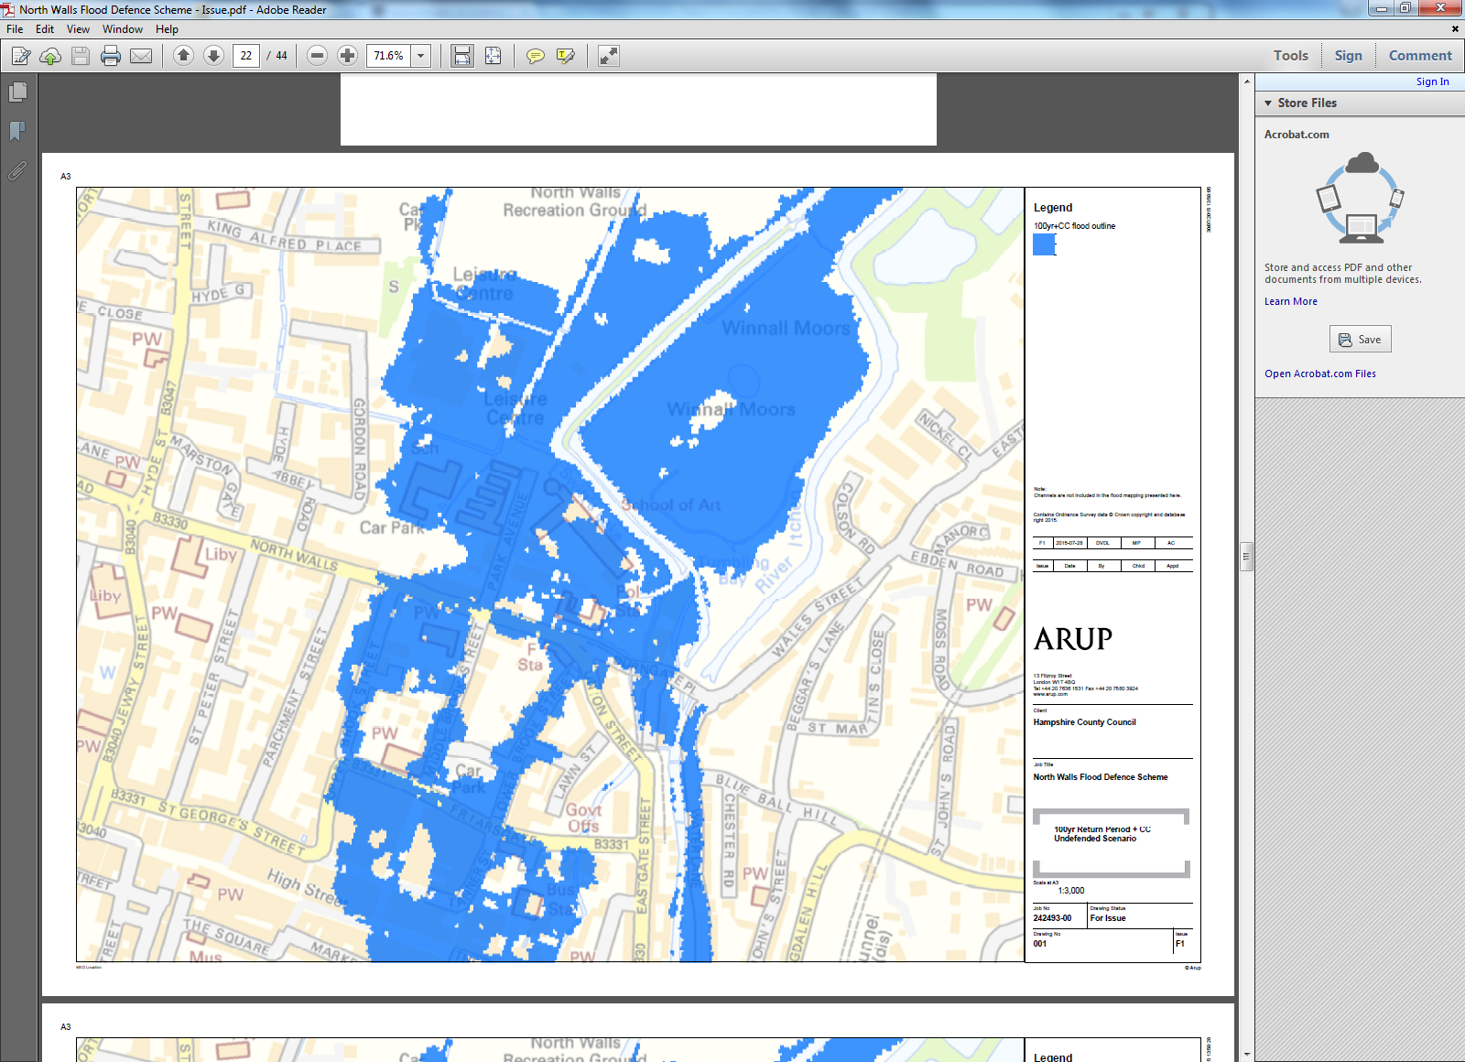
Figure 3 – 100yr Return period plus Climate Change UNDEFENDED scenario

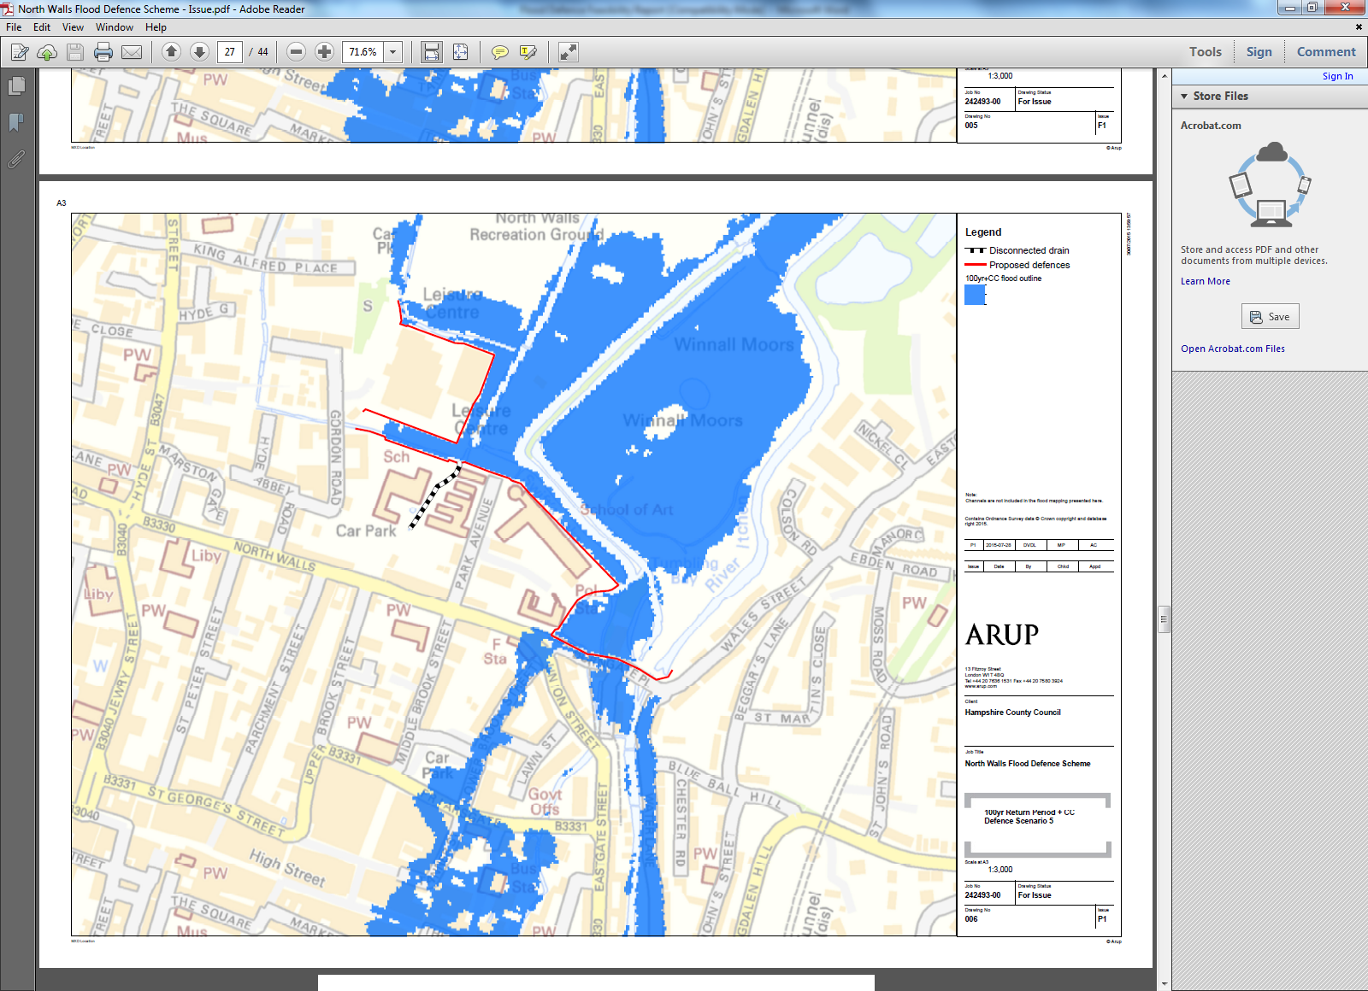
Figure 4 – 100yr Return period plus Climate Change DEFENDED scenario

The modelling indicates that there will be an increase in flood risk at the following locations:

- 29 to 47mm within Winnal Moors
- 11 to 32mm along Water Lane
- 7mm along The Weirs footpath, near Wharf Mill

The risk will be mitigated by the following factors:

- Winnall Moors is behind the Flood Defences and within the Flood plain area, the increase in water depths has no affect on properties
- The output from the flood model is incorrectly predicting flooding within Water Lane. Refer to Section 5.0 which demonstrates how this will be mitigated.
- The increase in flood level at this location is negligible, so there is no increase in risk to people or properties.

Discrepancy within the Flood Model

The newly constructed flood defence wall along Water Lane was added to the River Itchen corridor flood model. The model results indicate that flooding would still occur between a 1:25 year and 1:100 year plus climate change storm return period event.

The model indicates a breach of the river channel at 3 locations as indicated on an extract of the maximum flood depth 1:100yr return period +CC map below.
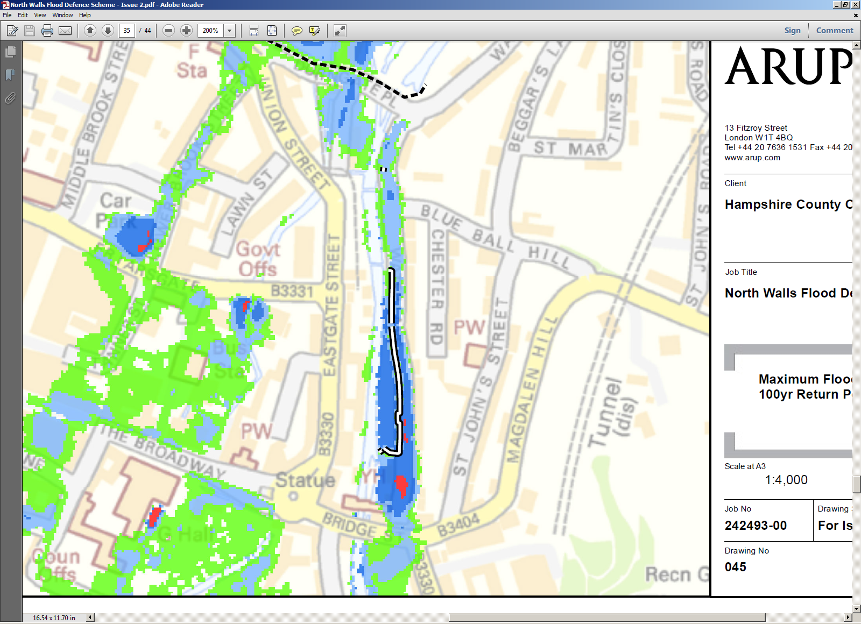
2) Model indicates a breach of the Channel along Water Lane.
3) Model indicates a breach of the Channel Between number 5 & 17 Blue Ball Court.
1) Model indicates a breach of the Channel at Southern Side of Durngate Bridge.
Figure 5 Extract of the maximum flood depth 1:100yr return period +CC map

This area is outside of the study area and the flood model has not been amended to reflect accurate existing ground level data. The ground surface data within the model at this location is currently based on LiDAR data. Having reviwed the more accurate topographical survey data the flooding shown is being exagerated for the following reasons:

- The flooding that is shown to occur at the southern side of the Durn Gate is unlikely to occur as a wall is present along this road. The level of the wall is significantly higher than the flood level and as such the water would not leave the channel at this location.
- The topographical survey levels in this area show that the existing ground levels are higher than the flood level and as such the water would not leave the channel at this location.
- There is a break between number 5 and 17 Blue Ball Court which introduces a risk of flood water leaving the channel and flooding Water lane. This risk is to be managed by placing sandbags between number 5 and 17 Blueball Court as part of the WCC flood action plan.

Budget Cost Estimate & Scheme Funding

A preliminary design for the flood defences has been carried out to enable a budget cost estimate of the construction works to be determined.

The works cost has been determined using the South East 7 (SE7) Framework tendered rates and the total cost estimate allowing for inflation is shown in Table 1.

Construction Costs | £654,000
Fee’s, surveys and supervision | £96,000
2016 Estimate Total | £750,000
Table 1 Budget Estimate Scheme Costs

The cost of the scheme will be met by Winchester City Council (WCC), Hampshire County Council (HCC), Southampton University & the Environment Agency (EA). Each party has tentatively stated that they are able to contribute the following.

Winchester City Council £240,000
Hampshire County Council £250,000
Southampton University £60,000
Environment Agency £213,000

If all of the above funding can be secured this will cover the cost of the proposed scheme.

A second option, including fees, which would not protect River Park Leisure Centre and Riverside Indoor Bowling Club has been estimated at a cost of £490,000

Cost benefit Analysis

There have been two significant flood events in Winchester within the last 15 years due to flooding from the River Itchen. The cost of these events to WCC, HCC, SU and the EA are summarised below.

2001/2002 Flood Event

Hampshire County Council

As a result of this flood event St Bedes School was damaged, with flood water affecting the whole footprint internally. The school had to be vacated and the flood damage repaired along with raising of the floors to reduce the risk of furure damage due to flooding.

Approximate cost £500,000

During this flood event a temporary school was built whilst St Bedes was being repaired.

Approximate cost £350,000

Total cost to Hampshire County Council £850,000

Winchester City Council

No data available

The Environment Agency

No data available

Southampton University (Winchester School of Art)

No data available

2013/2014 Flood Event

Hampshire County Council

HCC’s reactive maintenance team (working with WCC and EA partners) had to protect St Bedes school with sand bags and subsequent remedial work.

Approximate cost £30,000

Total cost to Hampshire County Council £30,000

Winchester City Council

WCC establish and ran an emergency control room and supplied sandbags.

Approximate cost £75,000

WCC submitted insurance claims for City Centre buildings (including RPLC) which were flooded.

Approximate value of claim £78,000

Total cost to Winchester City Council £153,000

Environment Agency

3400 sandbags provided and deployment of 50m of barrier at Park Avenue along with 5700 sandbags along Water Lane

Approximate cost £30,000

Note: Flood defence works undertaken in 2015 along Water Lane has reduced the future need of 5700 sandbags, the proposed North Wall flood defences will remove the requirement for 3400 sandbags and deployment of the 50m barrier. These can be used elsewhere in the County in other areas at risk of flooding.

£53,00.00+VAT for creating flood storage areas upstream of the A33/A34 Junction and on land east of the M3.

Approximate cost £53,000

Note: the proposed works would create a natural holding area north of River Park.

Total cost to the Environment Agency £83,000

Southampton University (Winchester School of Art)

Property damage

Approximate cost £37,600

Business interruption (hire of alternative accommodation).

Approximate cost £9,800

Total cost to the Southampton University £47,4 00

Combined Total Cost

 | 2000/2001 | 2013/2014
Hampshire County Council | £850,000 | £30,000
Winchester City Council | £---- | £153,000
Environment Agency | £----- | £83,000
Southampton University | £----- | £47,400
Total | £850,000 | £313,400

The Environment Agency has undertaken a review of the potential cost due to damage to properties and infrastructure should the 1:100 year plus climate change event occur.

The review looked at the following scenarios:

- Do minimum – this is the continuation of existing maintenance but no other structural work.
- Option 2 – flood wall, excluding section around leisure centre
- Option 3 – flood wall, including section around leisure centre

The cost savings in avoiding damage to properties and infrastructure were identified as follows:

- £129,3413.13
- £10,406,944.04
- £12,785,896.24

Conclusion

The proposed design solution will significantly reduce the risk of flooding to the north of Winchester city centre. It is hoped that through continued joint working with the EA, Winchester City Council, Hampshire County Council and Southampton University that a funding package can be agreed to enable the scheme to be implemented.
There are currently 58 dwellings identified at being at moderate risk and 16 dwellings with a significant risk of fluvial flooding from the River Itchen within the study site. The flood defence works would reduce the risk of flooding to these dwellings to low.

With an investment of £750,000 to enable the scheme to be implemented there is the potential to save £12,785,896.24 of costs due to damage should the 1:100 year plus climate change occur and the north of Winchester city centre be undefended.

The scheme would protect River Park Leisure Centre, St Bedes CE Primary School, Winchester School of Arts, residential properties in Park Road and reduces the risk of flooding in Brooks Street, Upper Brooks Street and High Street.

It also needs to be set against the reduction in the level of resources needed sandbag and protect this area which could de deployed elsewhere within the City or County.

