Community Governance Review

Littleton and Harestock
Parish Council

Local Government and Public Involvement
in Health Act 2007

Terms of Reference

Community Governance Review

Littleton & Harestock Parish Council

Local Government and Public Involvement in Health Act 2007

Terms of Reference

  - Aim of Review

This review will ascertain whether governance for the residents of Littleton and Harestock Parish Council, within the Winchester City Council boundary, would be best served by splitting the current parish council into two separate Parish Councils or other arrangements.

  - Why undertake a Community Governance Review?

Littleton & Harestock Parish Council has made a representation to Winchester City Council requesting that a Community Governance Review be undertaken “ to put in place strong boundaries and structures for the two very distinct and separate areas of Harestock and Littleton”. A Community Governance Review provides an opportunity for making recommendations with regards to establishing, aggregating, amalgamating or separating parishes, the name and style of a new parish and electoral arrangements.

Through its meeting of its Licensing and Regulatory Committee on 21 February 2018, Winchester City Council has therefore resolved to undertake a Community Governance Review pursuant to Part 4 of the Local Government and Public Involvement in Health Act 2007.

  - Scope of the Review

The review will specifically consider the composition and electoral arrangements of the residents living within the boundary of Littleton and Harestock Parish Council.

  - Who will undertake the Community Governance Review?

Winchester City Council is responsible for undertaking a Community Governance Review within its electoral area. The City Council is responsible for overseeing this process and officers will produce draft and final recommendations for consideration by the Licensing and Regulation Committee before any Order is made. Any final Order must be made by Full Council.

  - How long will the Community Governance Review take?

If an order is made, this will be done at the end of the year. There are various steps and consultation exercises to be undertaken between now and then and these are outlined in the timetable below.

  - Timetable for the review

Stage | What happens? | Timescales | Indicative dates
Commencement | Parishes/Ward/Officer check | December 2017
Preparation | Desk research and information gathering (extensive); delegations and authorities identified and Terms of Reference for the review are prepared and published. Consultations are prepared. | 3 months | December – April 2018
Stage One | Initial Submissions are invited | 3 weeks | May 2018
Stage Two | Consideration of Submissions received – Draft recommendations are prepared.  Licensing & Regulatory Committee | 1 week | May 2018  June 2018
Stage Three | Draft Recommendations, and the reasons for them, informing those with an interest for further consultation are prepared and published. | 8 weeks | June – August 2018
Stage Four | Consideration of submissions received – Final Recommendations are prepared | 8 weeks | August - September
Conclusion | Final Recommendations are published – concluding the review |  | October
Resolution | Council resolves to make a Reorganisation Order to put into effect any changes | If necessary | Next available Council Meeting

  - How will the review be conducted?

The Review will be conducted in accordance with the duties outlined in the Local Government and Public Involvement in Health Act 2007 and Guidance on these reviews published by the Department for Communities and Local Government in March 2010.

In accordance with Section 79 of the 2007 Act, the City Council will notify Hampshire County Council that a Community Governance Review will be undertaken.

In accordance with Section 93 of the 2007 Act, the City Council will consult with local government electors for the area under review; and any other person or body which appears to have an interest in the review.

In accordance with Section 93 of the 2007 Act, the City Council will also consult with local government electors for the area under review; and any other person or body which appears to have an interest in the review. The bodies include:
- Littleton & Harestock Parish Council
- Hampshire County Council
- Hampshire Association of Local Councils
- The Local Government Boundary Commission for England.
The consultation will also involve other relevant persons, including political parties and local community interest groups. The City Council will publish these Terms of Reference, any proposals made as a result of the review and any recommendations on its website.

The City Council will have regard to the need to secure that any community governance for the area under review reflects the identities and interests of the local community in that area and that it is effective and convenient. Relevant considerations will include the impact on community cohesion and the size, population and boundaries of the proposed area.

  - Options for Consideration

The City Council has prepared three possible outcomes to be put forward for consultation;
- Option 1: Position to remain unchanged and the Parish Council remains as it is.
- Option 2: Littleton and Harestock separate and each become their own Parish Council.
- Option 3: Littleton and Harestock separate. Littleton becomes its own Parish Council and Harestock joins the area of Winchester Town.

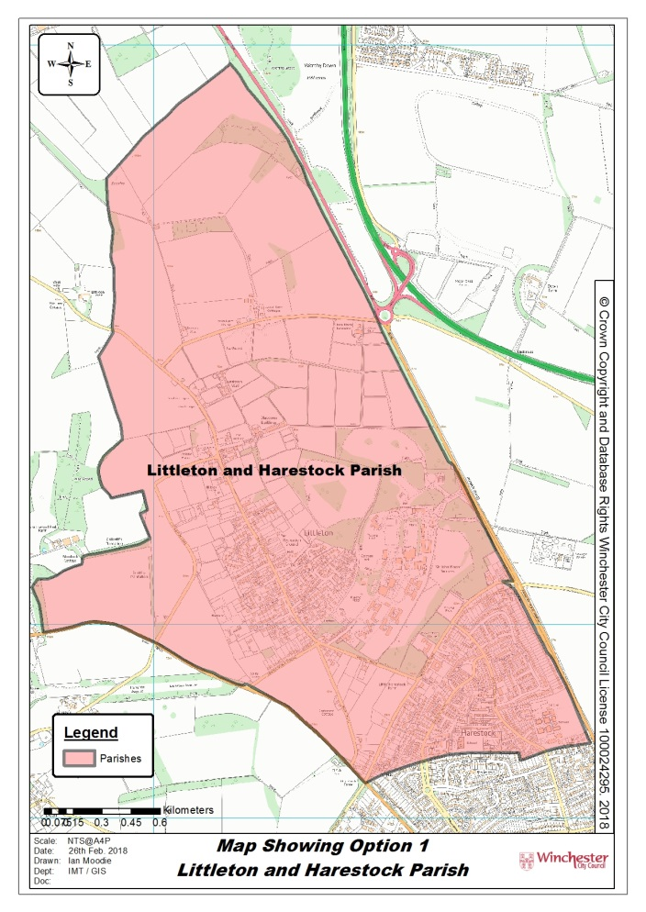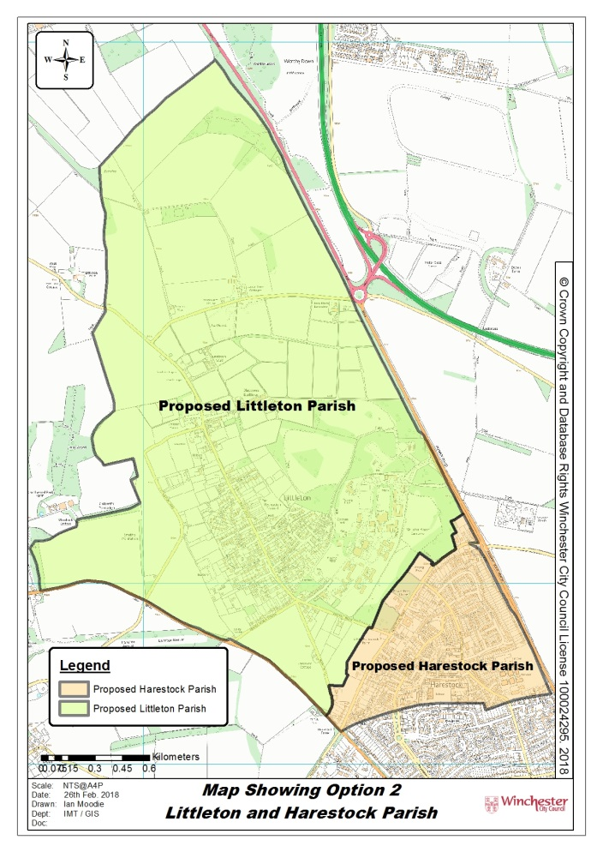

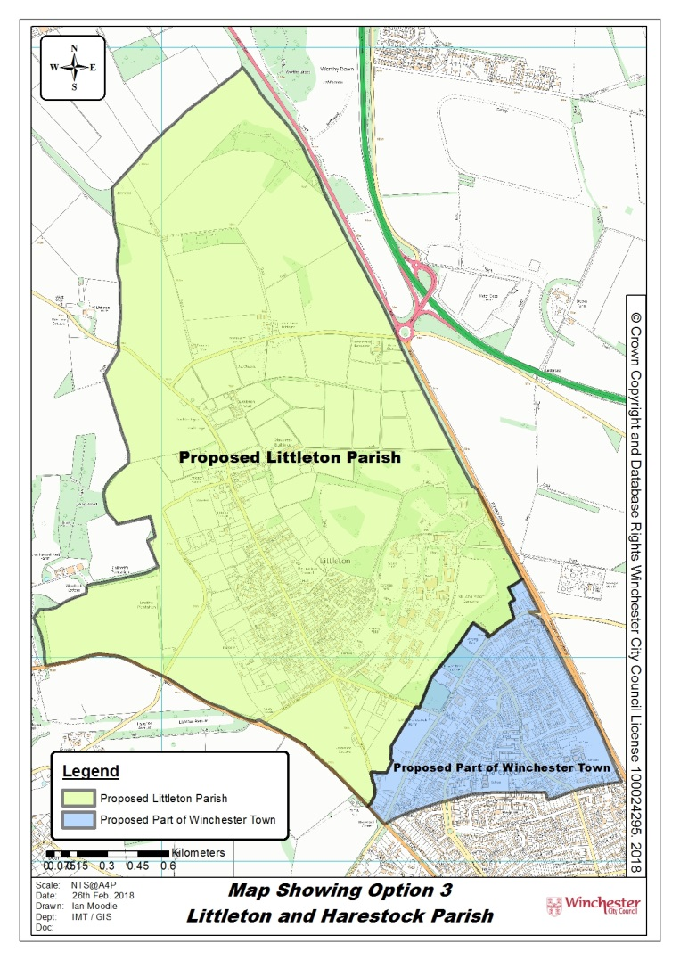

  - The conclusions for the Review

Following the conclusion of the review, if a new Parish or other Council is to be created, or if there is an amalgamation this will be done by way of a Reorganisation Order. A Reorganisation Order can be made at any time however the Order should take effect on the 1st of April following the date on which it is made. In this case if a Reorganisation Order is made in the Autumn of 2018, it would come into effect 1st April 2019.

  - Contact

Any queries in respect of this review process should be directed to Winchester City Council. Please contact via communitygovernancereview@winchester.gov.uk

City Offices, Colebrook Street, Winchester, Hampshire, SO23 9LJ
March 2018

