**PH Jones Summary Report**

Table of Contents

**Introduction3**

**Methodology3**

**Profiling questions4**

**Your heating appliance questions5**

Have you had a visit from PH Jones since they became the preferred contractor in October 2017?5

What type of heating appliance do you have?5

**Your PH Jones appointment questions6**

What was the reason for PH Jones’s last visit to your home?6

When an engineer last visited you, how did you know they were from PH Jones or one of their specialist contractors??6

Did you have to ask the engineer to produce his Photo ID or did the engineer freely offer it to you?7

Which of the following best describes the last appointment you had arranged with PH Jones?7

If the engineer had to make a second visit to repair the fault when was this return appointment agreed with you?8

When you last reported a repair, did PH Jones attend at the appointment time and date you originally agreed with the council?8

**Your PH Jones experience questions9**

How would you rate the engineer’s conduct and behaviour?9

How many visits did the last fault take to fix?9

When PH Jones last visited you, did the engineer leave a customer checklist?10

How long after your heating appliance was last serviced did you receive the test certificate?10

Have you ever had to chase an unfinished PH Jones repair?11

If you have ever needed to contact PH Jones’ office direct by telephone, approximately how long did it take for the telephone to be answered?11

If you have ever spoken to PH Jones office/admin staff, how did you find them?12

How would you describe PH Jones’ reliability?12

Since PH Jones have taken over the responsibility for the maintenance of your heating system and/or smoke alarms how would you describe the service?13

How would you rate PH Jones overall?13

Would you recommend PH Jones to a friend?14

Would you be interested in taking part in a small group to further discuss the service provided by PH Jones?14

**Your PH Jones appointment questions profiled by heating type15**

What was the reason for PH Jones’s last visit to your home?15

When an engineer last visited you, how did you know they were from PH Jones or one of their specialist contractors??16

Did you have to ask the engineer to produce his Photo ID or did the engineer freely offer it to you?17

Which of the following best describes the last appointment you had arranged with PH Jones?18

If the engineer had to make a second visit to repair the fault when was this return appointment agreed with you?19

When you last reported a repair, did PH Jones attend at the appointment time and date you originally agreed with the council?20

**Your PH Jones experience questions profiled by heating type21**

How would you rate the engineer’s conduct and behaviour?21

How many visits did the last fault take to fix?22

When PH Jones last visited you, did the engineer leave a customer checklist?23

How long after your heating appliance was last serviced did you receive the test certificate?24

Have you ever had to chase an unfinished PH Jones repair?25

If you have ever needed to contact PH Jones’ office direct by telephone, approximately how long did it take for the telephone to be answered?26

If you have ever spoken to PH Jones office/admin staff, how did you find them?27

How would you describe PH Jones’ reliability?28

Since PH Jones have taken over the responsibility for the maintenance of your heating system and/or smoke alarms how would you describe the service?29

How would you rate PH Jones overall?30

Would you recommend PH Jones to a friend?31

Would you be interested in taking part in a small group to further discuss the service provided by PH Jones?32

**Introduction**

In October 2017, PH Jones replaced Liberty Gas as Winchester City Council's preferred contractor to carry out  the servicing and responsive repairs to heating appliance and smoke detector/s. PH Jones are responsible for the maintenance of the heating systems (except those with electric storage or quantum heaters) and smoke alarm/s throughout the housing stock. For those tenants with non-gas heating systems (eg. oil, biomass, air source heat pump, solid fuel, and bottled gas) another specialist contractor (employed by PH Jones to carry out the works their behalf) may have visited to repair or service the appliance.

There is already an established system of feedback though the use of the green Customer Care Cards, the decision was taken to conduct this survey to give a much broader view on how the service provided by PH Jones is being received by customers.

**Methodology**

This survey was an online survey, sent to all tenants for whom Winchester City Council hold an email address. It was also posted on the Winchester City Council and Winchester City Council Tenant Involvement Facebook pages and the Winchester City Council Twitter page.

An incentive was offered as a thank you for taking part. Someone, chosen at random from all Winchester City Tenants who participated in the survey will receive a £50 Love2Shop voucher. The winner of this incentive will be chosen at random using a random number generator selected by one of the current involved tenants. Confidentiality will be maintained through this process by only choosing a number which corresponds to details on a password protected spreadsheet.

The consultation ran from 11th January 2019 to 8th February 2019.

The initial email was sent to 2,839 email addresses. Of these there was a successful delivery rate of 92.7%[1] and an email open rate of 49.9%[2] and a click rate of 11.9%[3].

Two weeks after the initial email was sent a reminder email was sent. This email had an open rate of 40.4% and a Click rate of 6.6%.

The survey was successfully delivered to 2,627 email addresses. There were 369 completed responses. This is 14% of the successful delivery rate.

When analysing the responses the ‘don’t know / can’t remember’ and ‘not answered’ responses have been removed. The numbers have then been recalculated. The responses shown in this report represent the recalculated numbers and percentages. This will explain the change in totals throughout.

**Profiling Questions**

Age profiling comparison to whole tenant population[4]

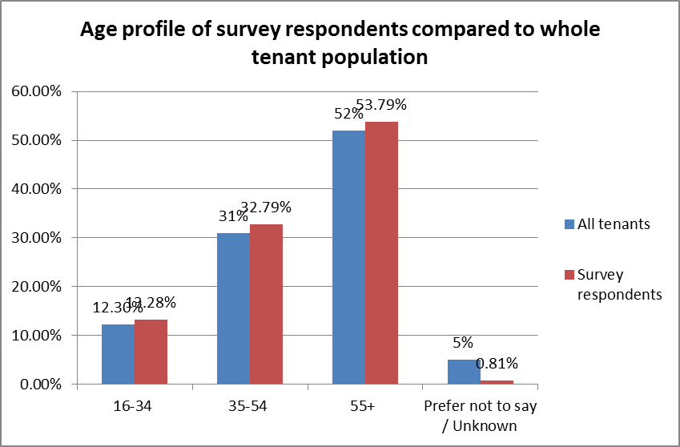

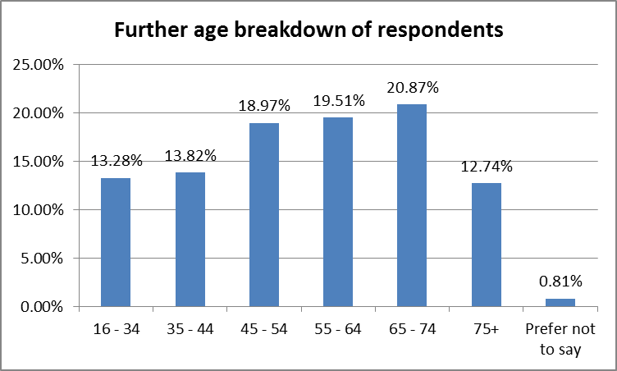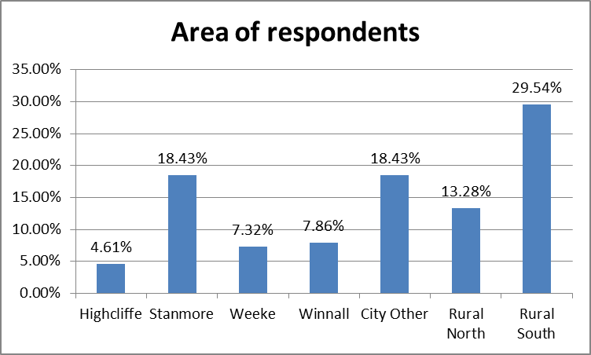

**Your heating appliance**

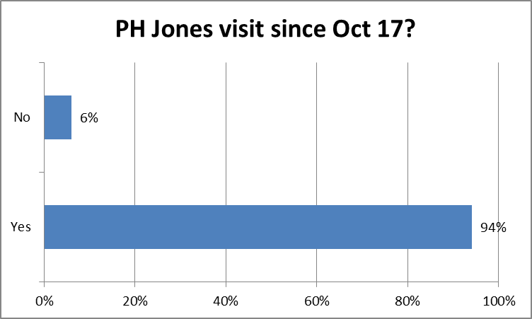



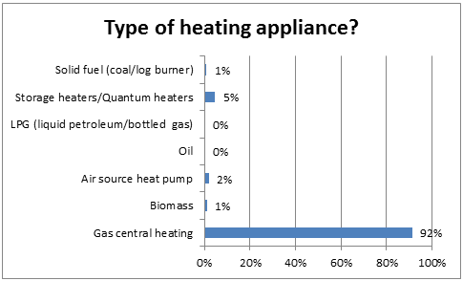



**Your PH Jones appointment**

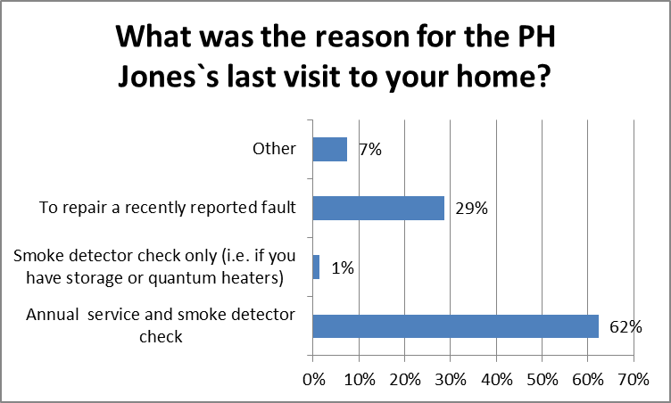



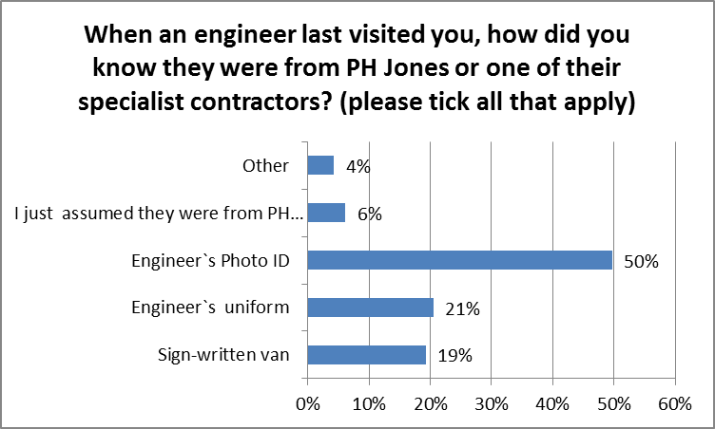



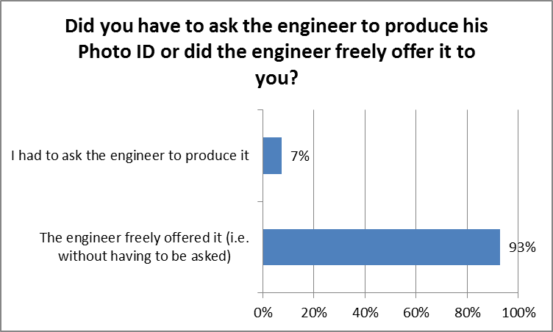



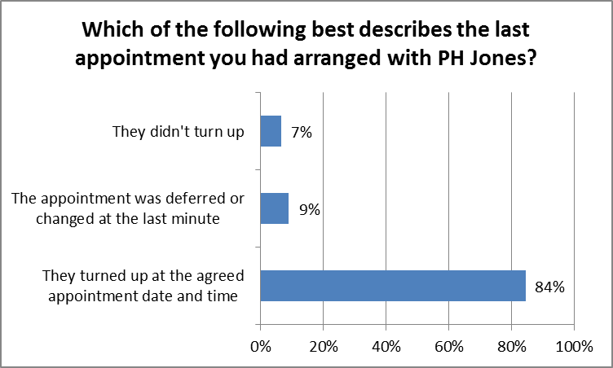



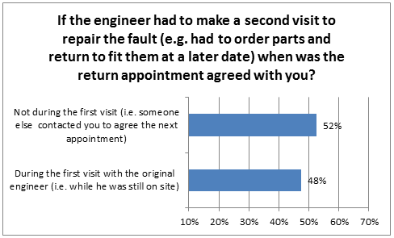



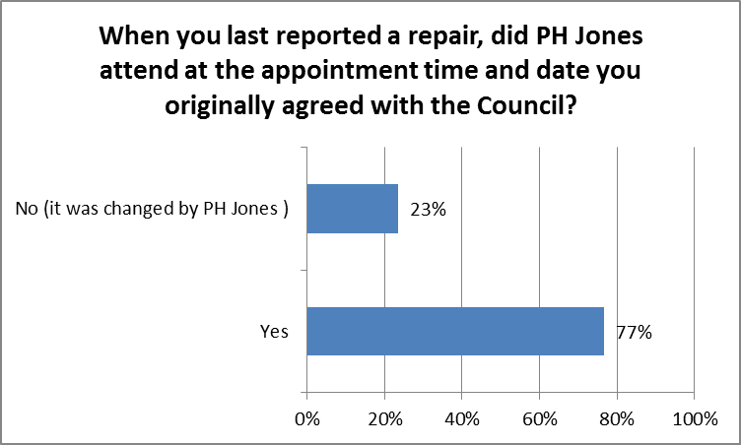



**Your experience**

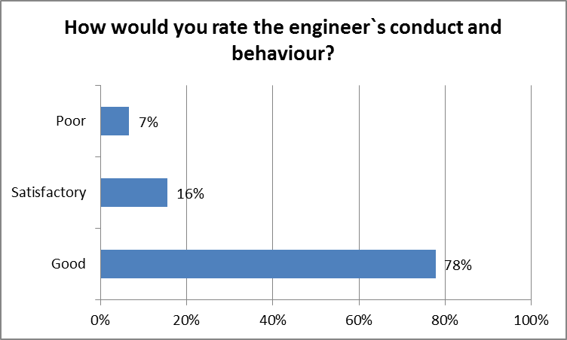



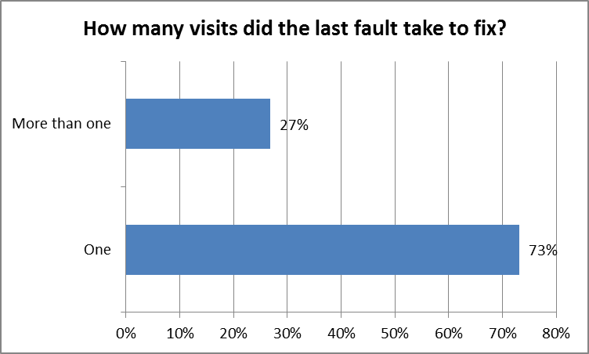



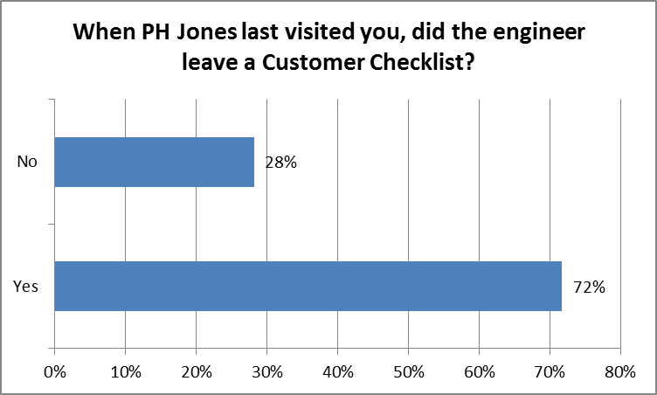



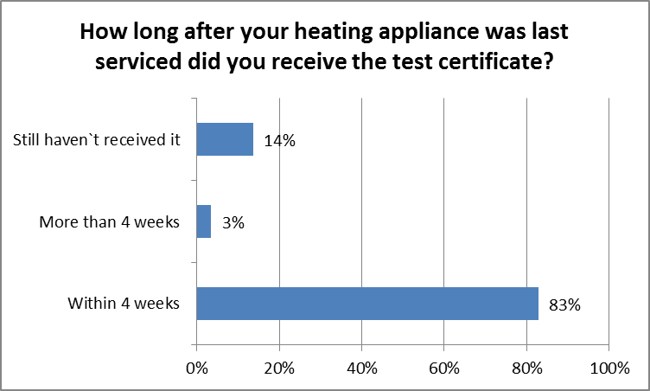



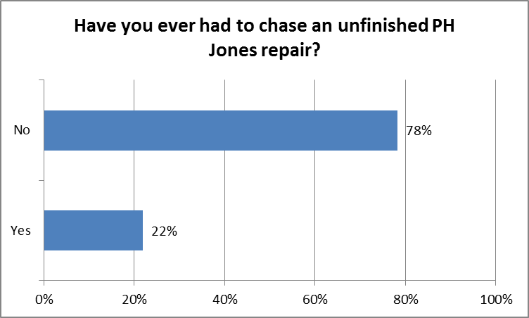



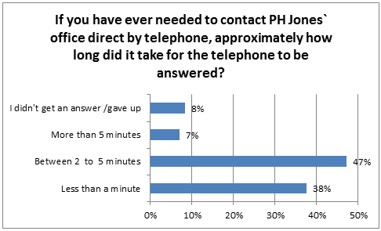



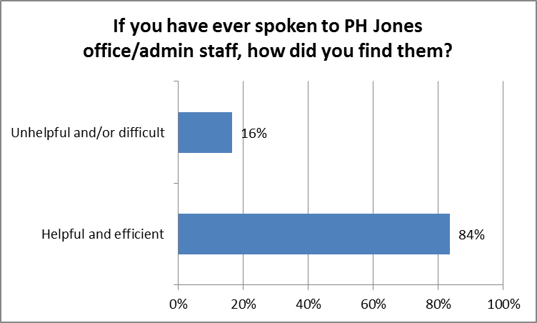

|  |  |  |
| --- | --- | --- |
| **If you have ever spoken to PH Jones office/admin staff, how did you find them?** |  | Total |
| Helpful and efficient | 84% | 152 |
| Unhelpful and/or difficult | 16% | 30 |
|  | 100% | *182* |



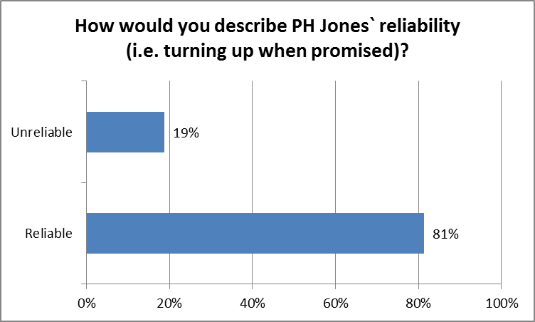



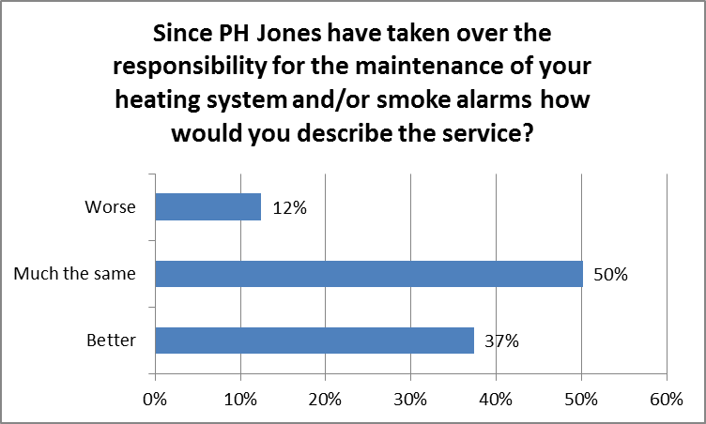



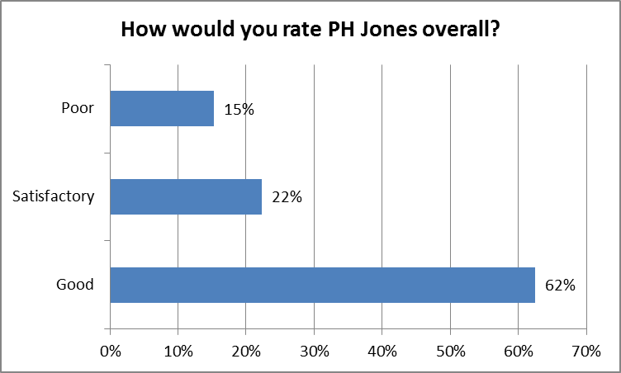



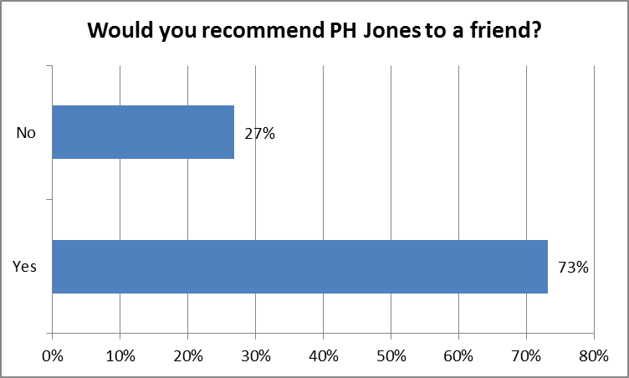



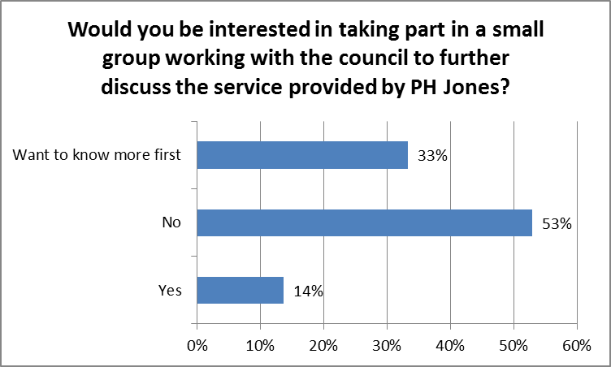



**‘Your appointment’ questions profiled by heating type**

Oil and LPG have been left out of the graphs as there were no returns for these heating types.

Please note that there may be a slight discrepancy between the totals listed on these charts and graphs in comparison to the non profiled questions above. This is due to the removal of the ‘don’t know’ and ‘not answered’ responses.

For example; someone may have ticked that they have gas central heating but couldn’t remember what the last appointment was for. They will therefore not show when profiled.

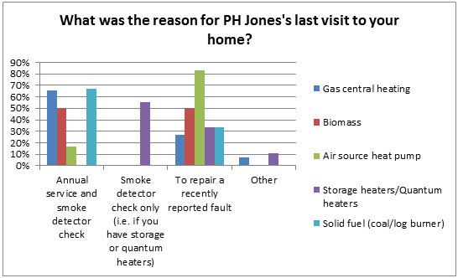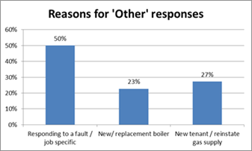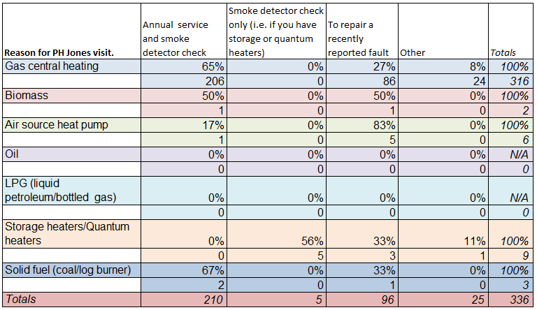

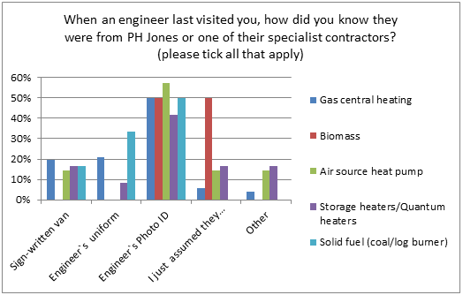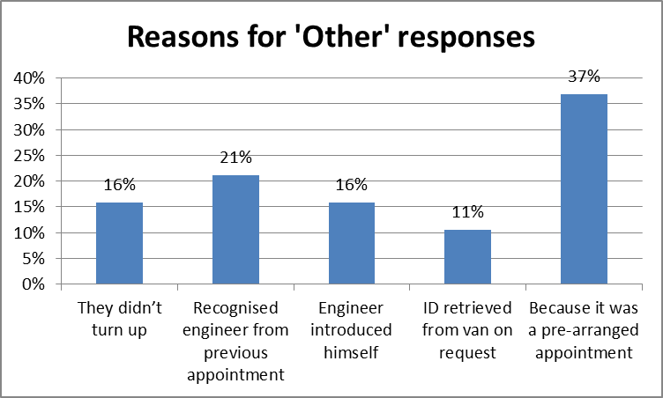



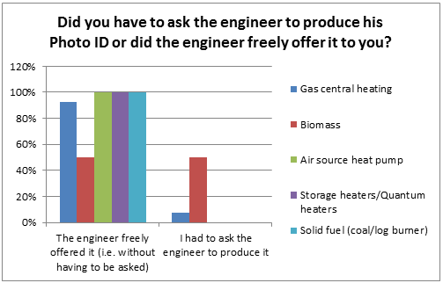



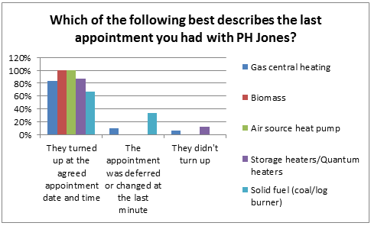



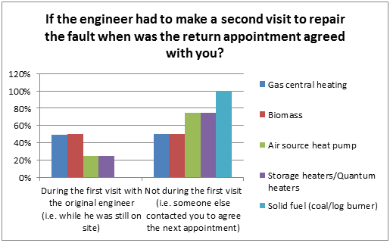



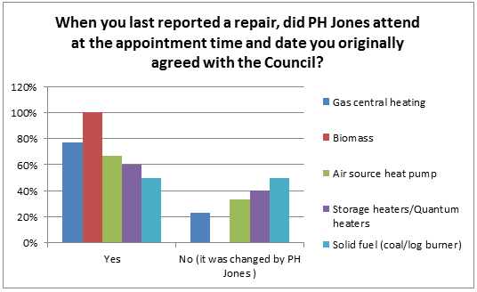



**‘Your experience’ questions profiled by heating type**

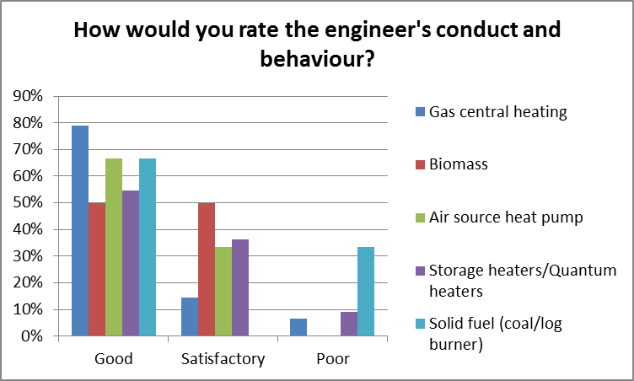

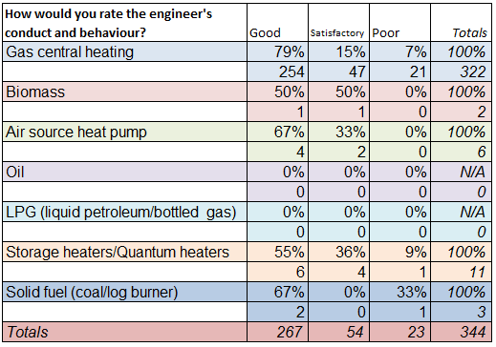

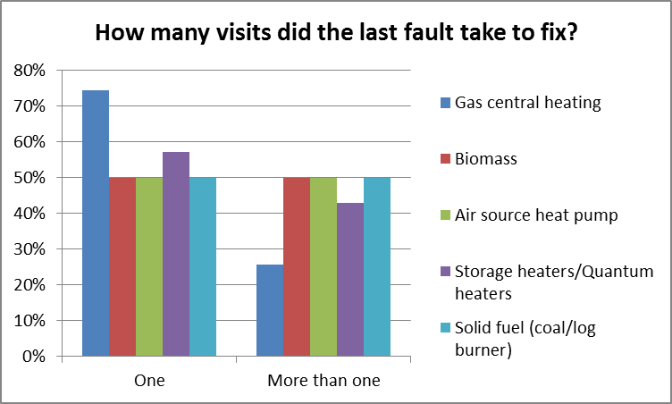



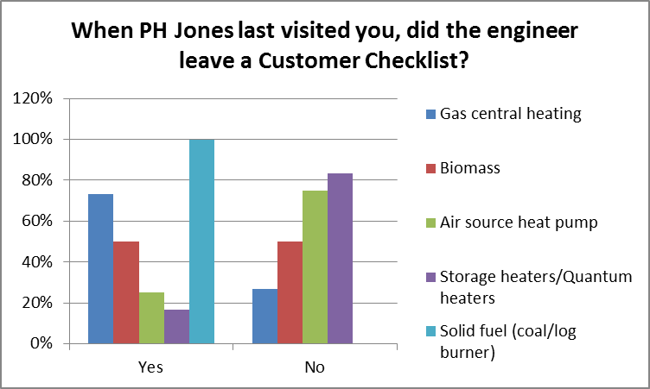



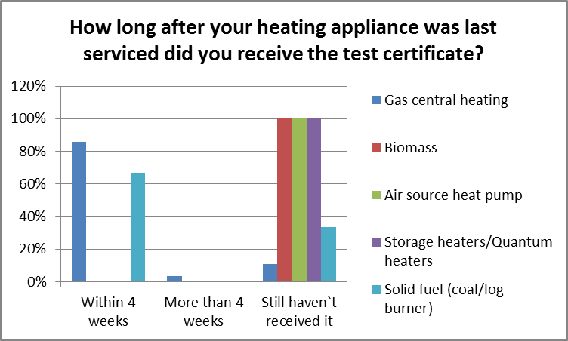

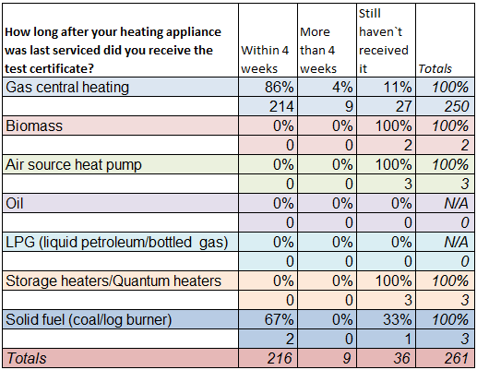

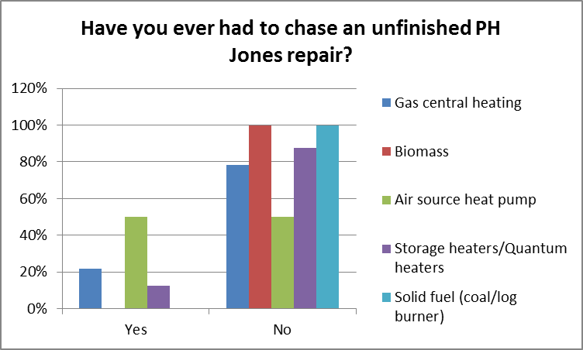



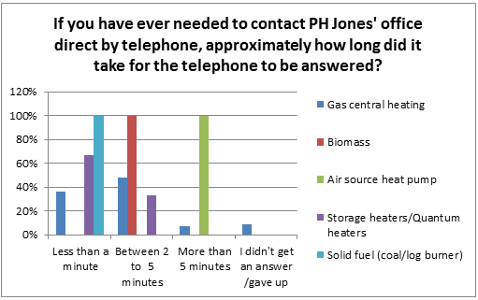



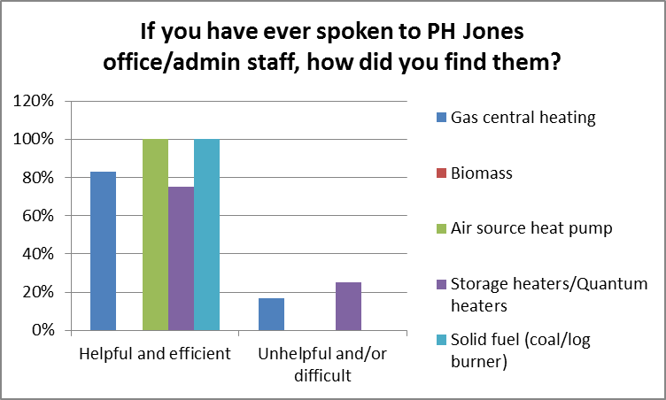



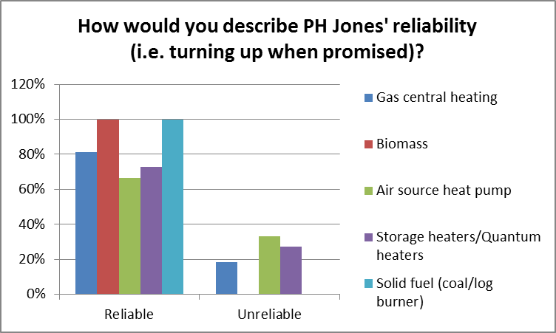



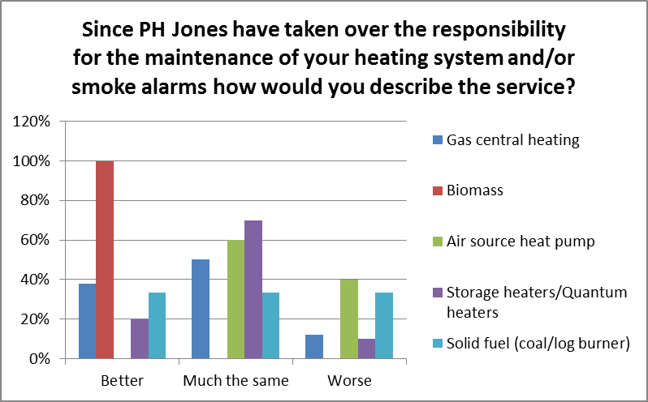



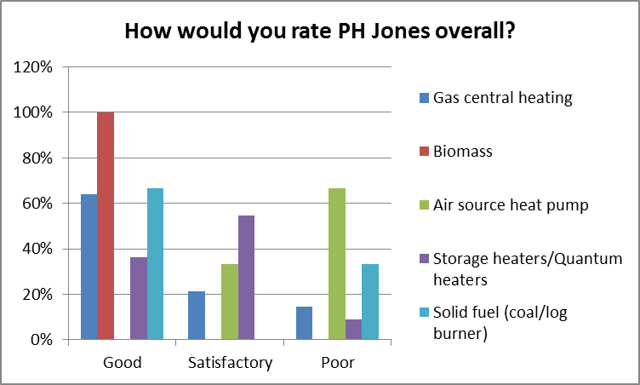

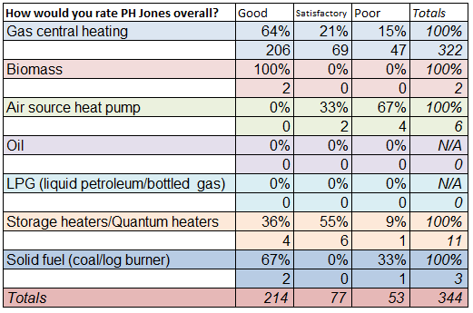

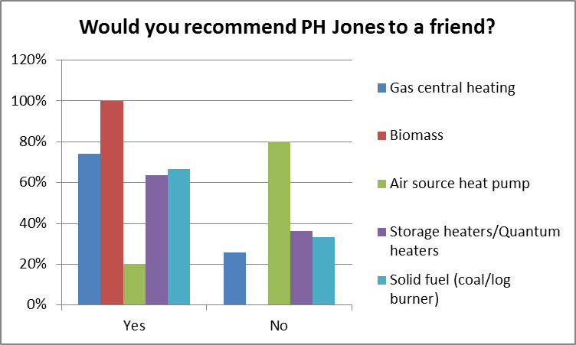



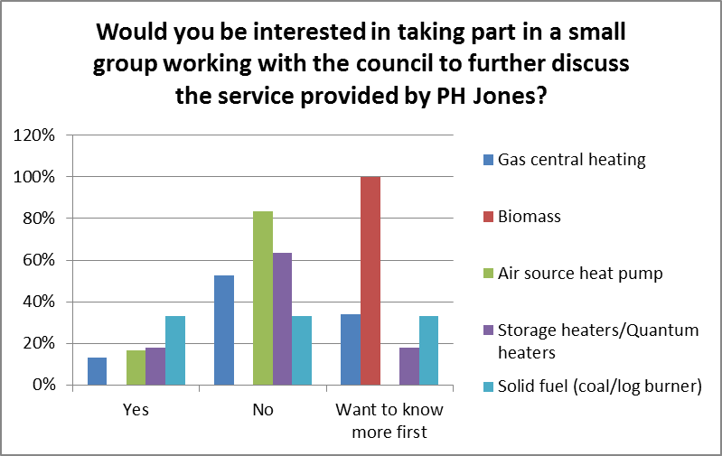

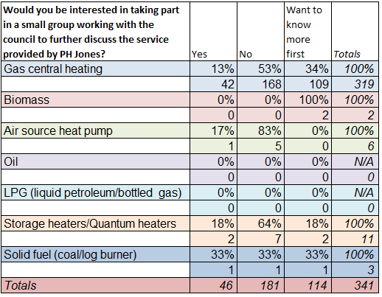

1. 206 emails bounced back and 5 unsubscribed.
2. The industry average for local government is 22.2% according to the email provider Mail Chimp.
3. Click tracking allows you to see if contacts have clicked the links in the email. The industry average for local government is 2.5% according to email provider Mail Chimp.
4. All tenant figure is taken from a Richard Boardman report as at 31.01.18